Name: _________________________________ Date: _________________________

LO: To use technical language
Equipment carried _____________________________________________________________________________________________________________________________________________________________________________________________________________
Head ________________________________________________________________________________________________________________________________________________________________________________________________________________________________________

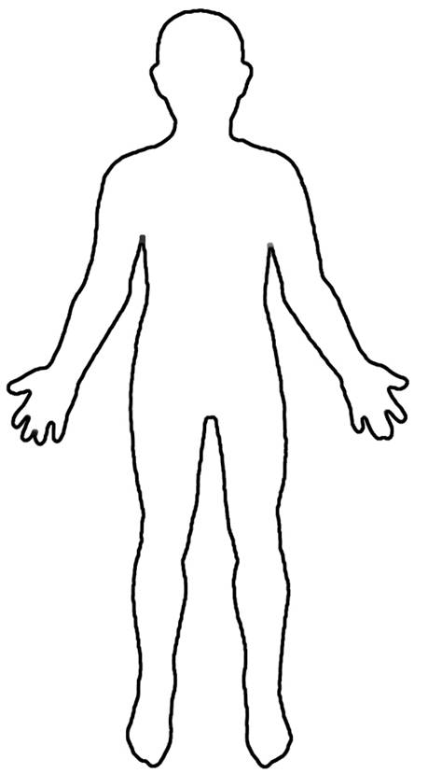
Body __________________________________________________________________________________________________________________________________________________________________________________________________________________________________________________________________________________________________________
Legs and feet ___________________________________________________________________________________________________________________________________________________________________________________________________________________________________________________________________________________________________________
Hands ____________________________________________________________________________________________________________________________________________________________________________________________________________________________________________________________________________________________________________________________________________________________________________________________________________________________________________________

