Thursday 11th February

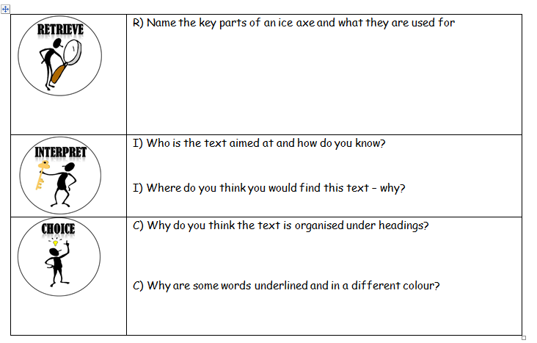LO: To read and understand a text