**10.2.21**

**LO: To suggest the meaning of a story from the Gospels**

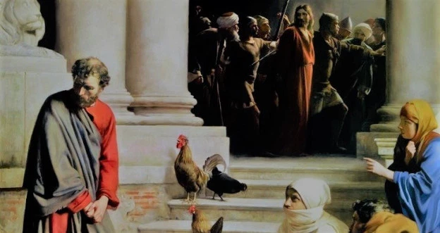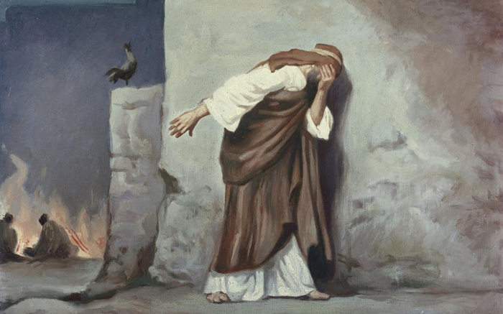Your first task is to annotate around the pictures. Draw arrows coming off them and think carefully.

Write down your ideas on:

* What they might be about
* What is similar/different?
* The colours used and how the artist portrays the same scene from the Bible.

**Now answer the following questions:**

1. Use the lines of continuum below to mark on what you think the story is about. Make sure you give a reason for your answer using the story as evidence:

Lying

Breakfast

Love

Trust

Betrayal

Forgiveness

Faith

Doubt

1. Who was hurt the most in the story? Why do you think this?

_____________________________________________________________________________________________________________________________________________________________________________________________________________________________________________________________________________________________________________________________________________________________________________________________________________________________________________________________________________________________________

1. Who repaired the hurt? How did they do this? Hint: think about your answer to question 2.

____________________________________________________________________________________________________________________________________________________________________________________________________________________________________________________________________________________________________________________________________________________________________________________________________

1. What does the story teach about trust? Explain your answer.

___________________________________________________________________________________________________________________________________________________________________________________________________________________________________________________________________________________________________________________________________________________________________________________________________________________________________________________________________________________________________________________________________________________________________________________________________________________________________________________________________________________________________________________________________________________________________________________________________________________________________________________________________________________________________________________________________________________________________________________________________________________________________________________________________________________________________________________________________________________________________________________________________